

Lab 1: Create a Virtual machine in the portal

At the end of each lab, any resources you created in your account will be preserved. Some Azure resources, such as VM instances, may be automatically shut down, while other resources, such as storage services will be left running. Keep in mind that some Azure features cannot be stopped and can still incur charges (i.e. Azure Bastion). To minimize your costs, delete all resources and recreate them as needed to test your work during a session.

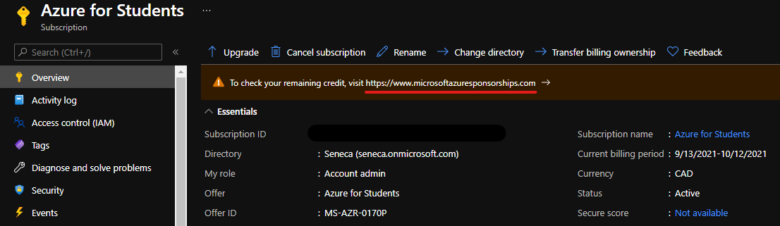

Reference: [AZ-900T0X-MICROSOFTAZUREFUNDAMENTALS](https://microsoftlearning.github.io/AZ-900T0x-MicrosoftAzureFundamentals)

# 01 - Create a virtual machine in the portal

In this walkthrough, we will create a virtual machine in the Azure portal, connect to the virtual machine, install the web server role and test.

**Note**: Take time during this walk-through to click and read the Informational icons.

# Task 1: Create the virtual machine (10 min)

In this task, we will create a Windows Server 2019 Datacenter - Gen1 virtual machine.

1. Sign in to the [Azure portal (https://portal.azure.com)](https://portal.azure.com/?azure-portal=true).
2. From the **All services** blade, search for and select **Virtual machines**, and then click **+ Add** and choose **+Virtual machine**.
3. On the **Basics** tab, fill in the following information (leave the defaults for everything else):

| Settings | Values |
| --- | --- |
| Subscription | **Choose your subscription** |
| Resource group | **myRGVM** (create new) |
| Virtual machine name | **myVm** |
| Location | **(US) East US** |
| Image | **Windows Server 2019 Datacenter - Gen1** |
| Size | Standard D2s v3 |
| Administrator account username | **azureuser** |
| Administrator account password | **Pa$$w0rd1234** |
| Inbound port rules - Allow select ports | **RDP (3389)** and **HTTP (80)** |
|  |  |

1. Switch to the Networking tab, and look for the **Select inbound ports**:

| Settings | Values |
| --- | --- |
| Select inbound ports | **HTTP (80), RDP (3389)** |
|  |  |

1. **Note** - Verify that both port 80 and 3389 are selected
2. Switch to the Management tab, and in its **Monitoring** section, select the following setting:

| Settings | Values |
| --- | --- |
| Boot diagnostics | **Disable** |
|  |  |

1. Leave the remaining defaults and then click the **Review + create** button at the bottom of the page.
2. Once Validation is passed click the **Create** button. It can take anywhere from five to seven minutes to deploy the virtual machine.
3. You will receive updates on the deployment page and via the **Notifications** area (the bell icon in the top menu).

* **Verify Port 80 and 3389 were opened**

# Task 2: Connect to the virtual machine

In this task, we will connect to our new virtual machine using RDP.

1. Search for **myVM** and select your new virtual machine.

**Note**: You could also use the **Go to resource** link on the deployment page or the link to the resource in the **Notification** area.

1. On the virtual machine **Overview** blade, click the **Connect** button and choose **RDP**.

[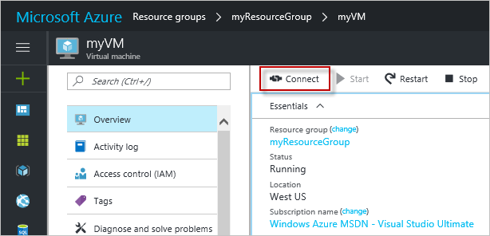](https://microsoftlearning.github.io/AZ-900T0x-MicrosoftAzureFundamentals/Instructions/images/0101.png)

**Note**: The following directions tell you how to connect to your VM from a Windows computer. On a Mac, you need an RDP client such as this Remote Desktop Client from the Mac App Store and on a Linux computer you can use an open source RDP client.

1. In the **Connect to virtual machine** page, keep the default options to connect with the public IP address over port 3389 and click **Download RDP File**.
2. **Open** the downloaded RDP file and click **Connect** when prompted.

[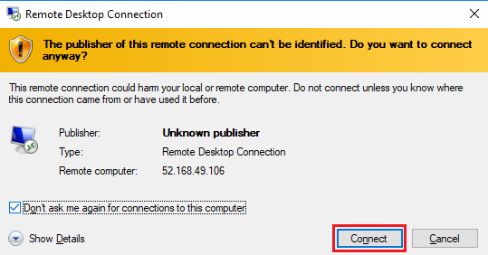](https://microsoftlearning.github.io/AZ-900T0x-MicrosoftAzureFundamentals/Instructions/images/0102.png)

1. In the **Windows Security** window, select **More choices** and then **Use a different account**. Provide the username (.\azureuser) and the password (Pa$$w0rd1234). Click **OK** to connect.

[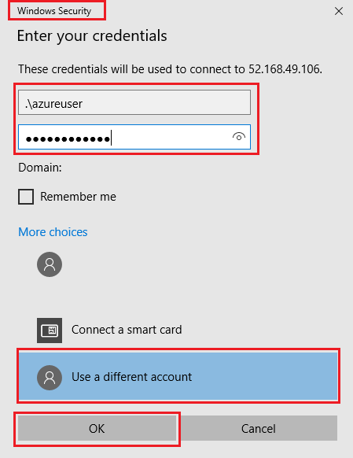](https://microsoftlearning.github.io/AZ-900T0x-MicrosoftAzureFundamentals/Instructions/images/0103.png)

1. You may receive a certificate warning during the sign-in process. Click **Yes** or to create the connection and connect to your deployed VM. You should connect successfully.

[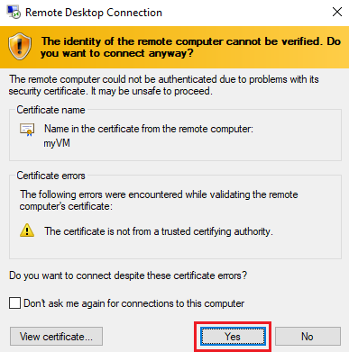](https://microsoftlearning.github.io/AZ-900T0x-MicrosoftAzureFundamentals/Instructions/images/0104.png)

Congratulations! You have deployed and connected to a Windows Server virtual machine in Azure

# Task 3: Install the web server role and test

In this task, install the Web Server role on the server and ensure the default IIS welcome page can be displayed.

1. Open up a PowerShell command prompt on the virtual machine, by clicking the **Start** button, typing **PowerShell**, right clicking **Windows PowerShell**, and selecting **Run as administrator** in the right-click menu.

[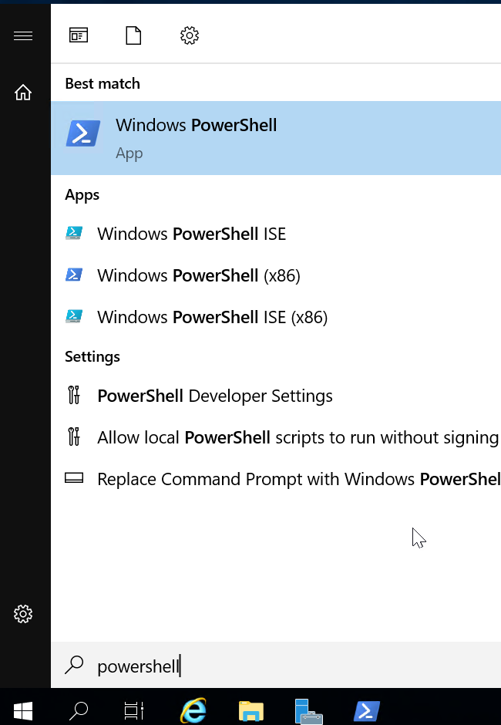](https://microsoftlearning.github.io/AZ-900T0x-MicrosoftAzureFundamentals/Instructions/images/0105.png)

1. Install the **Web-Server** feature in the virtual machine by running the following command in the PowerShell command prompt. You can copy and paste this command.

CodeCopy

Install-WindowsFeature -name Web-Server -IncludeManagementTools

1. When completed there will be a prompt stating **Success** with a value **True**. You do not need to restart the virtual machine to complete the installation. Close the RDP connection to the VM.

[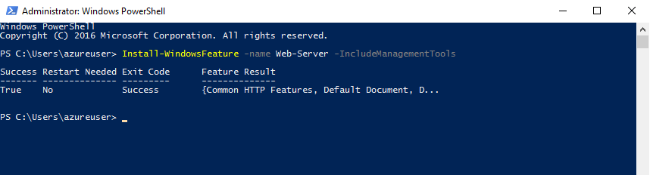](https://microsoftlearning.github.io/AZ-900T0x-MicrosoftAzureFundamentals/Instructions/images/0106.png)

1. Back in the portal, navigate back to the **Overview** blade of myVM and, use the **Click to clipboard** button to copy the public IP address of myVM, open a new browser tab, paste the public IP address into the URL text box, and press the **Enter** key to browse to it.

[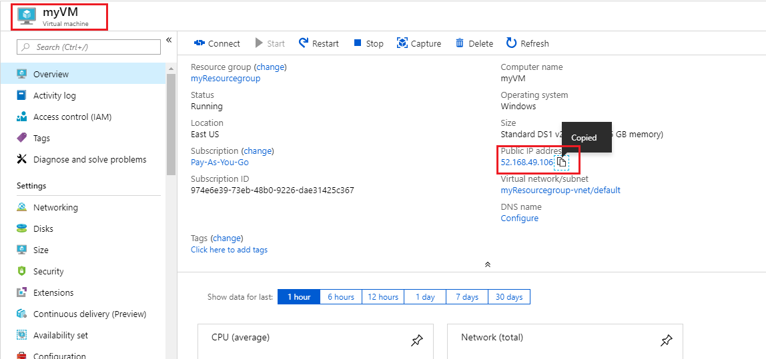](https://microsoftlearning.github.io/AZ-900T0x-MicrosoftAzureFundamentals/Instructions/images/0107.png)

1. The default IIS Web Server welcome page will open.

[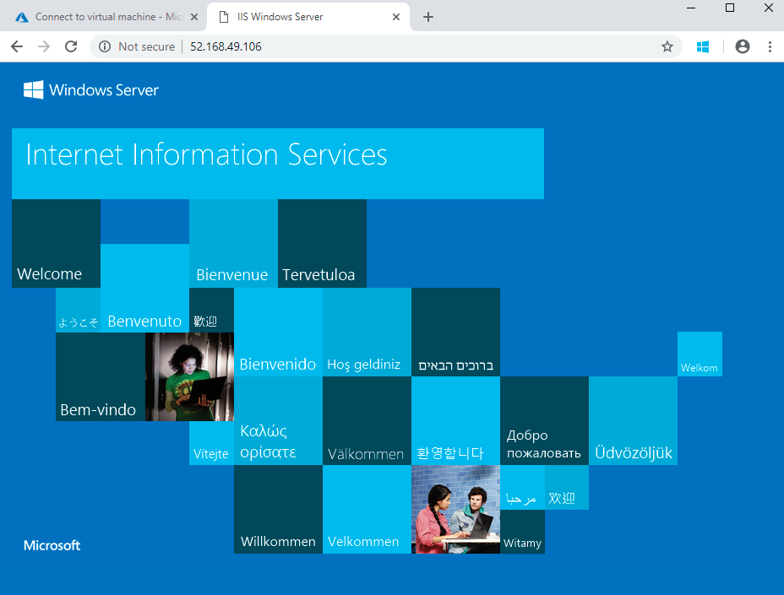](https://microsoftlearning.github.io/AZ-900T0x-MicrosoftAzureFundamentals/Instructions/images/0108.png)

Modify the default website title to your student ID (i.e. dtrinh1) instead of “IIS Windows Server”.

Congratulations! You have created a web server that is accessible via its public IP address. If you had a web application to host, you could deploy application files to the virtual machine and host them for public access on the deployed virtual machine.

**Note**: To avoid additional costs, you can remove all resources in the resource group. Search for resource groups, click your resource group, and then delete the resources within the resource group. **DO NOT DELETE YOUR RESOURCE GROUP.**

# Submission Requirements

Submit a screenshot with the following information:

Screenshot #1:

* Access to your webpage using an external IP address
* Webpage with the title modified to your student ID
* 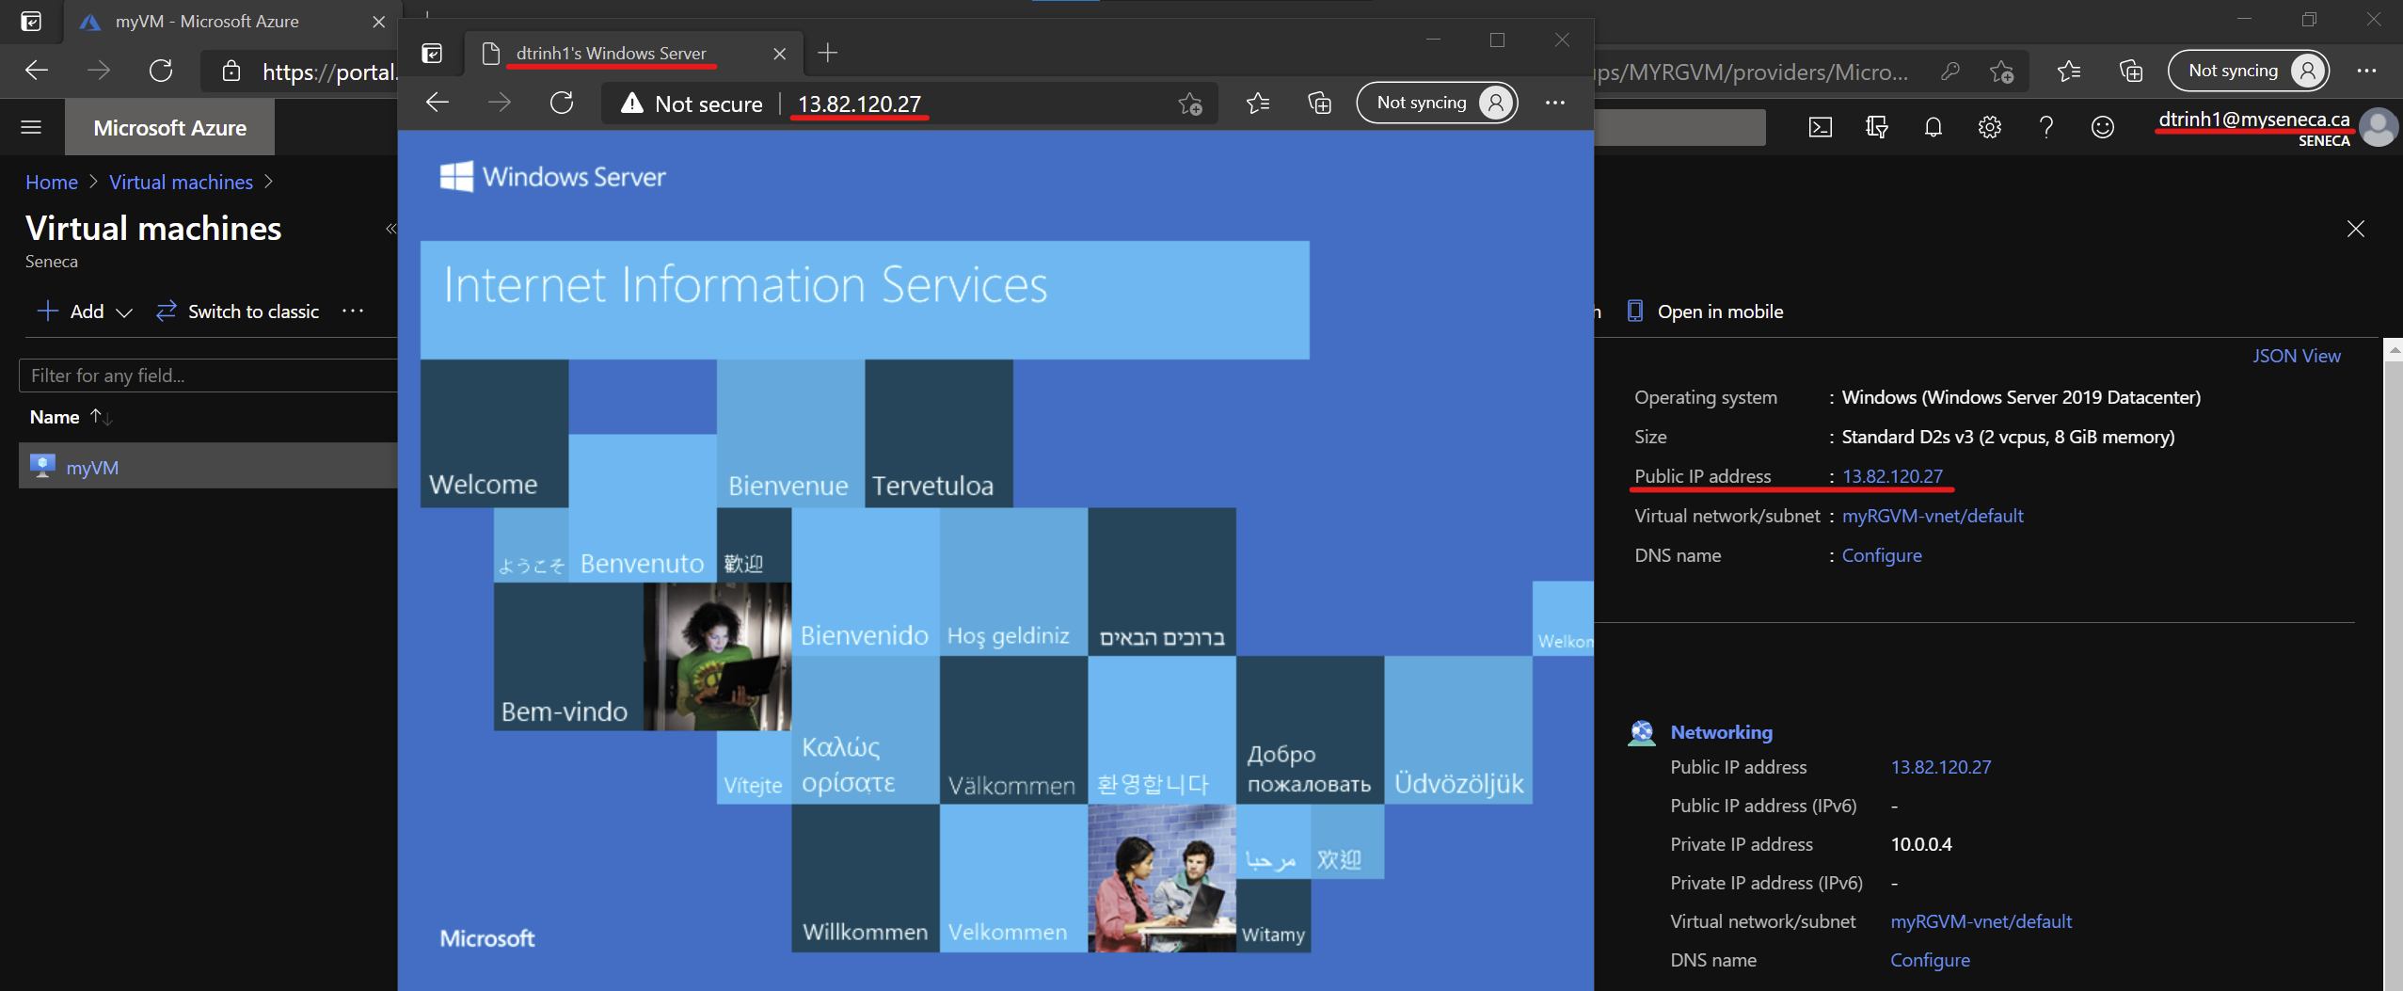The Azure Portal with your login ID [requires another browser window]

Screenshot #2:

* Successful deletion of resources within resource group. **DO NOT DELETE YOUR RESOURCE GROUP!**

